Renju lesson on March 21, 2002

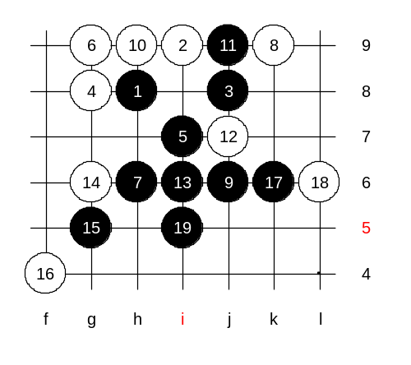
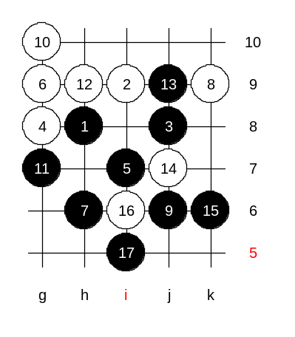
Hello everyone! Welcome to Online Renju Class. We have already checked two possible 4th moves of i3 opening. Let us vote for the new 4th move today. Which one you want to study first? We will study 4-g8 as most of you suggested. Black has at least 2 winning moves here. Do you know them? Yes, i7 and j9 are the best ones. We begin with i7, that is considered as the main 5th. Any suggestions for white's next move? Sure, g9 is very active, and we need to know how to deal with it. Is here anyone who would like to try the black win attack? Then I would just play the white stones. Since nobody agreed to show, I do it myself. But we should look the board instead of book. Sometimes book is not the best helper. Can anyone prove that 9-h9 is necessary? In my book, it is said like this: It is also possible to play 9-h9, etc, but it somewhat weakens black structures (probably still wins though). And the diagram on screen now is from my book. We do not usually play unnecessary threes unless we have to.

This is another solution. Black wins anyway.

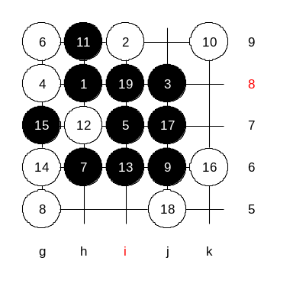

Another 8th move. Which 9th is correct? Black will not play a four because it is not necessary!! We check 10-k9 as the most interesting defense. What can white do here now after the 15th move? Who wants to show win here now? Wsbza, please.

This 6th move was finished. How about the next 6th?

OK, j6, here we go!
I prefer 7-k9. There may be other 7th moves, too, but k9 is simple enough.
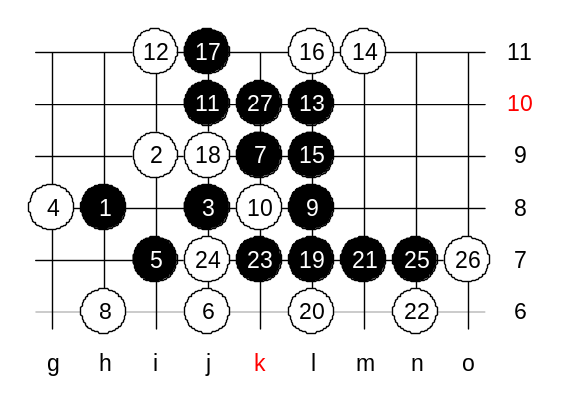
Who is ready to show black win, say "me"! Please, shadowyes!
We just saw an example attack in case of 8-h6. now we change to upper 8th move.

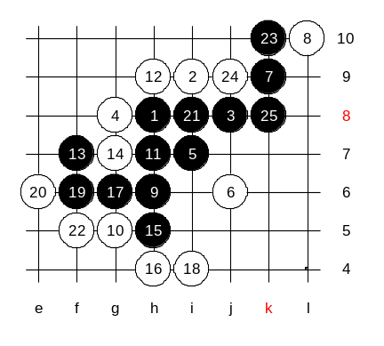

Who is ready to show black win here, say "me"! wsbza, please!
Good, the idea similar the one on my book.

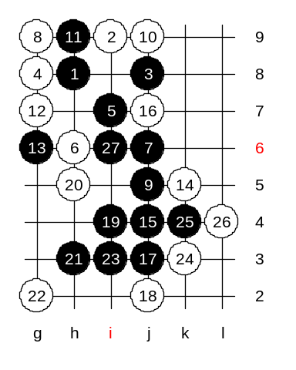

6-h9 is our last block. Who knows black win here?
ok, since most of you insist 9-j5, we will try it. :)
Where should the 13th move be played? Ok, g6. Who is ready to show black win? Please, ASV777. Good win!

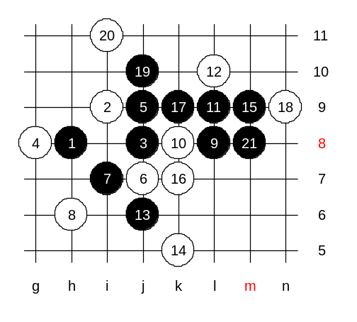

This is the second 5th move.
Today, I introduce one my game I played in 1990, just in this pattern. A bit untraditional thought.

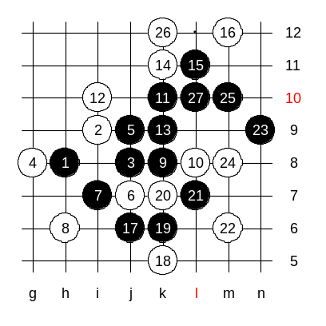
I played 9-L8 because it felt interesting. The traditional style here should be 9-k8.
Who is ready to show win? Good, shadewawa.

We end now! :) Surprise!

